Friday Problem Solving Challenge
Work your way through these challenges. How many can you complete? Be a YETI!

Challenge 1
30 cakes are arranged in an array. Some of the cakes are hidden.
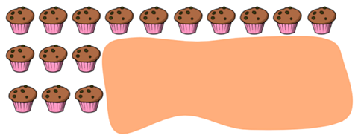

How many cakes are hidden?

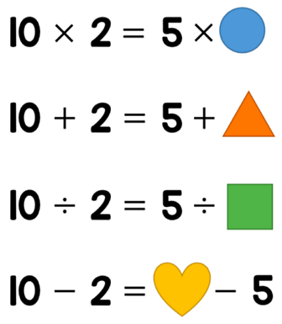
Challenge 2
Work out the missing numbers.
Think. Balance, like a scale.

Challenge 3
Danni has these four digit cards.

Danni uses all four cards to make two 2-digit numbers.
She then adds the two numbers together.

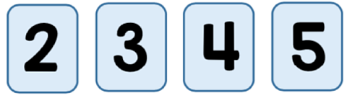
What is the greatest total she can make?

Challenge 4
Sonny buys 2 pencils and 3 rulers. Each pencil costs 69p.
Sonny pays with a £5 note and receives £1.07 change.

How much does a ruler cost?

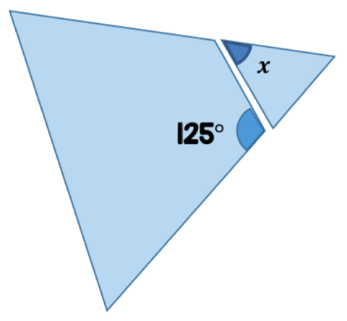
Challenge 5
Adam has an equilateral triangle.
He cuts a corner off the triangle.
Here are the two pieces.

What is the size of the angle marked x?
Remember: The angles on a straight line add up to 180 degrees.

Challenge 6
Here are two rectangles. The two rectangles are put on top of each other.
They are lined up so the black circles overlap.
The shaded area shows where the two rectangles overlap.

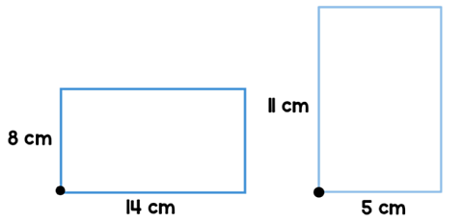
What is the area of the non-shaded parts of the shape?

